1. Project Overview
This project explores customer purchasing habits using transaction data from 3,900 orders across multiple product categories. The objective is to reveal insights into spending trends, customer groups, product preferences, and subscription activity to support strategic business planning.
2. Dataset Summary
- Total Records: 3,900
- Number of Columns: 18
- Key Attributes:
  - Customer demographics: age, gender, location, subscription status
  - Purchase details: product, category, amount spent, season, size, color
  - Shopping behavior: discount usage, promo code application, prior purchases, buying frequency, review ratings, shipping type
  - Missing Values: 37 entries absent in the review_rating field
3. Exploratory Data Analysis in Python
Data preparation and cleaning were conducted using Python:
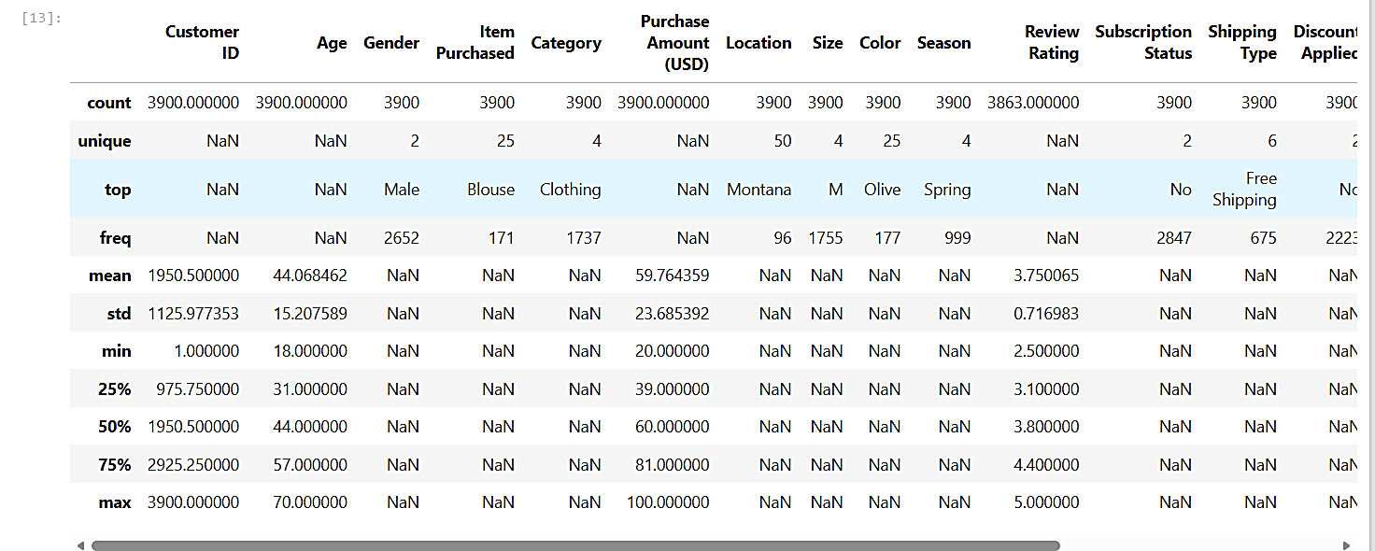
- Data Import: Loaded the dataset with pandas.

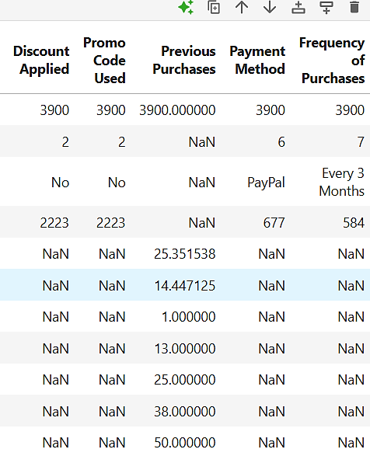

- Initial Review: Applied df.info() for structure and .describe() for statistical overview.
- Handling Missing Data: Filled null values in review_rating using the median rating per product category.
- Column Formatting: Converted column names to snake_case for consistency.
- Feature Engineering:
• Created an age_group variable by binning ages.
Derived purchase_frequency_days from transaction dates.
- Redundancy Check: Determined that promo_code_used overlapped with discount_applied and removed it.
- Database Integration: Connected the cleaned dataset to MySQL for structured analysis.

4. SQL-Based Analysis
Using MySQL, several business-focused queries were executed:
1 Revenue by Gender: Compared total sales generated by male and female customers.
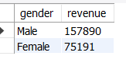

2. High-Spending Discount Users: Identified 839 customers who used discounts yet spent above the average purchase value.
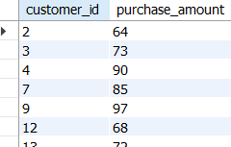

Total 839 Customers Found

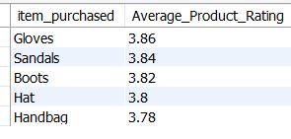
3. Top 5 Products by Rating: Listed products with the highest mean review scores.

4. Shipping Type Comparison: Analyzed average spending between Standard and Express delivery options.
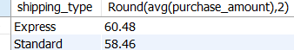

5. Subscribers vs. Non-Subscribers: Compared average spend and overall revenue between subscription holders and non-subscribers.
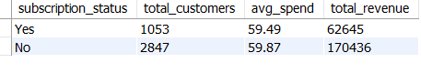

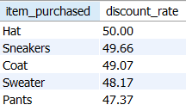
6. Discount-Dependent Products: Highlighted five products most frequently purchased with discounts.

7.Customer Segmentation: Classified customers into New, Returning, and Loyal groups based on purchase history.
